Assignment #10 SNA Gephi by Joshua Troup

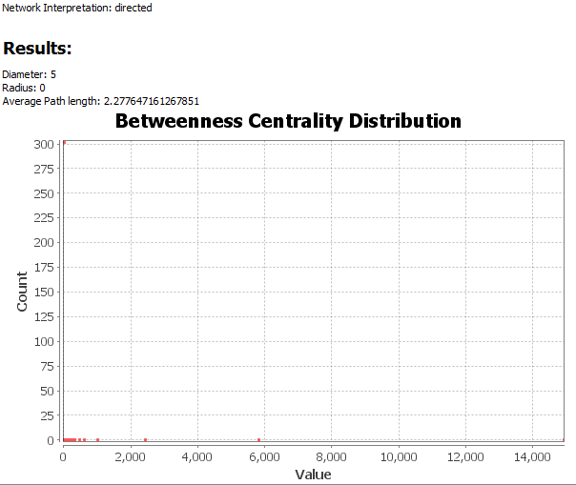

1. From the initial network graph, answer the following along with screenshot showing

• Number of edges = **2932**

• Number of nodes = **396**

• Is it a directed graph or undirected? **Directed**

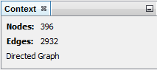

2. To determine the number of connections each node has, what is the average degree for this network? (click average degree under statistics and answer)

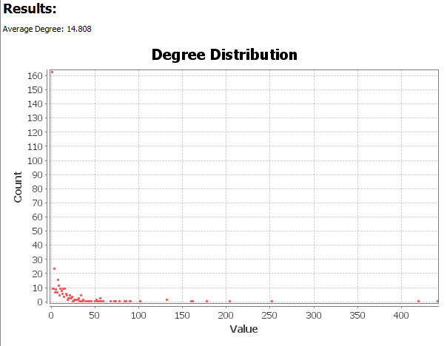

**Average Degree = 14.808**